To: Director of Operations, PJM Interconnection LLC

From: Aakash Kotha, Arpit Agarwal, Avi Manawat

Subject: Energy Usage Forecasting Results.

This summary forecasts the energy usage which ensures that PJM meets the changing energy demands.

**EXECUTIVE SUMMARY**

**MAJOR FINDINGS**

This analysis found that average daily usage of energy is around 17000 Watts [see Exhibit A].The energy usage is inversely related to the Temperature i.e increase in temperature there is a decrease in energy usage [see Exhibit B]. The critical temperature is found to be 285 Kelvin [see Exhibit C]. The number of passenger arrivals is neither increasing nor decreasing over time. Also we can see that in winters the energy usage is more this might be due to the increased number of usage of heaters.

**RECOMMENDATIONS:**

* Due to COVID -19 the energy consumption might increase as people spend more time at home. Setting a daily consumption limit warning will help people keep the consumption within limit.
* More substations need to be added or increase the capacity of energy production to meet the rapidly increasing population energy demands.
* Spreading awareness about saving electricity that would avoid unnecessary wastage of resources.
* Since electricity demand is low during mild season, states with mild temperatures can assist other states that have extreme temperatures with electricity supply

**ANALYTICAL OVERVIEW**

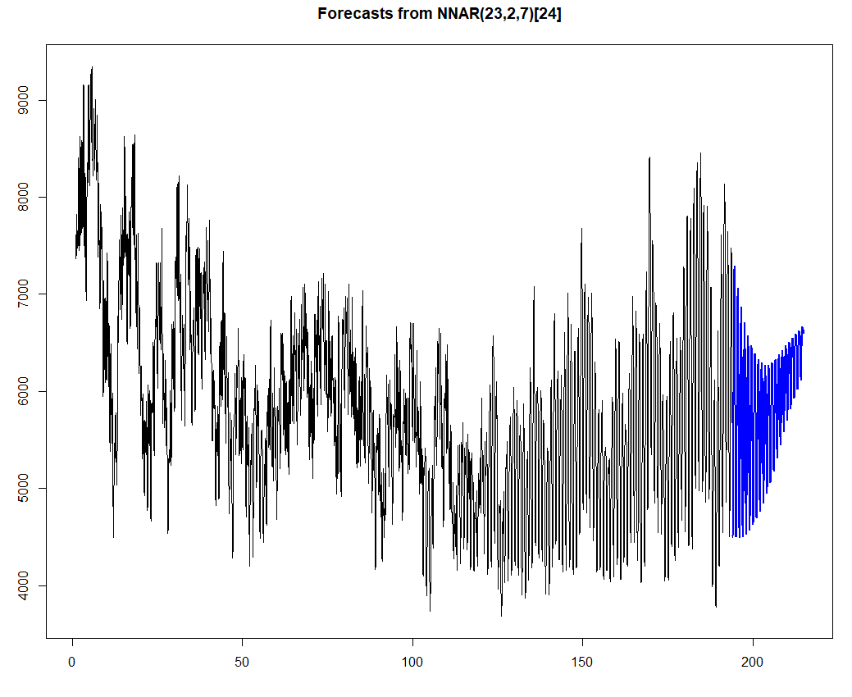

The objective of this analysis is to forecast the energy usage for the upcoming 3 months i.e May, June and July. The analysis is based on the energy usage data over a 6 year period i,e from 2013 to 2019. All the models were based on the data of years 2018 and 2019. The findings from the model have been applied to the entire data for the forecast. The best model chosen was **Neutral network (ntetar)** as it was simple, suitable for the data and had high accuracy [Exhibit D]. This analysis determines that the hourly and monthly energy usage patterns are best projected by a simple forecasting method that uses the energy usage of the same time period of previous years.

**APPENDIX**

Exhibit A: Energy usage pattern

**R Code:**



**Output:**

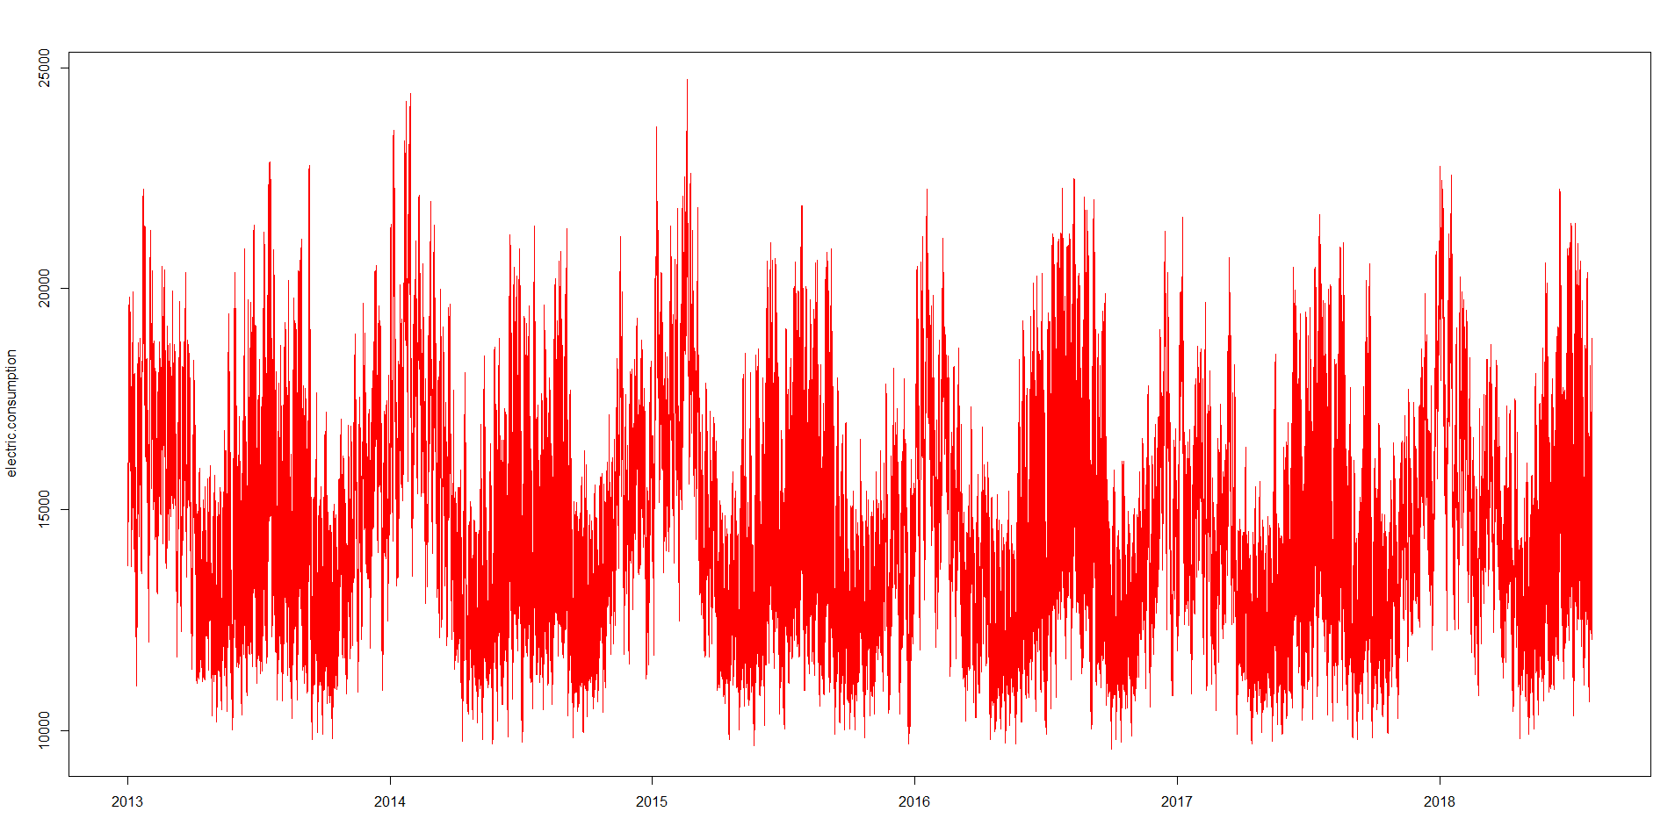

Exhibit B: Temperature and Energy Usage

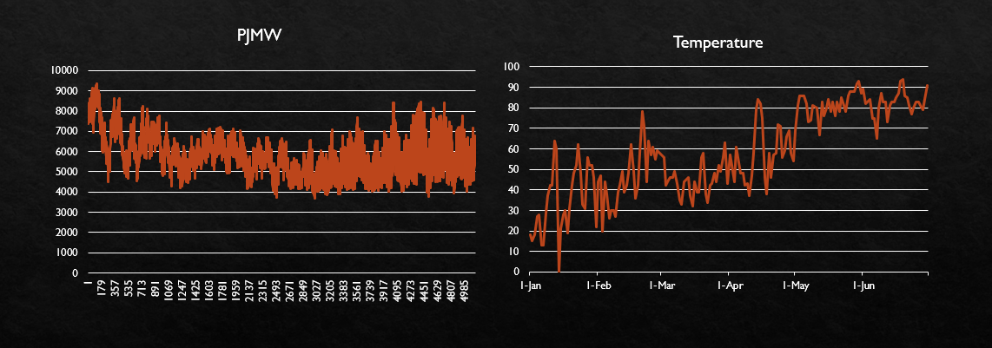

Exhibit C

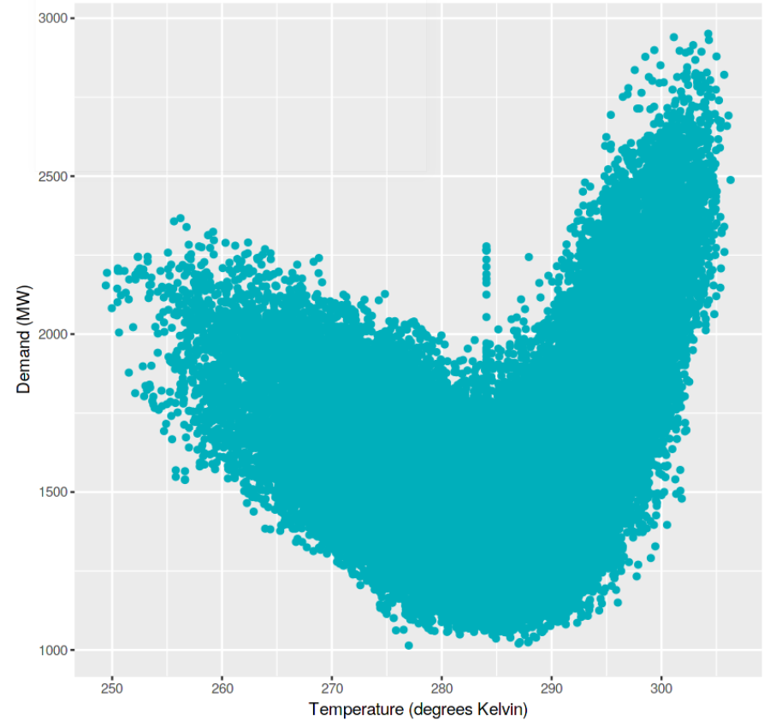

Exhibit D – Model accuracy

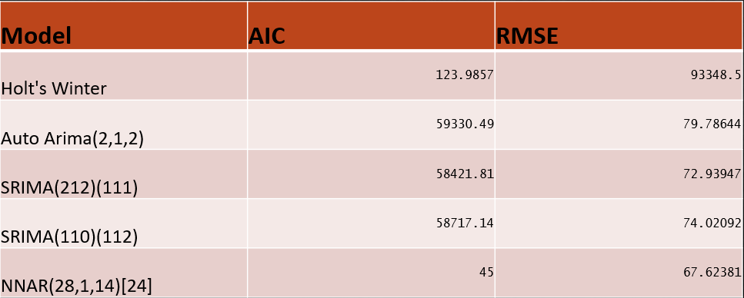

**SUPPORTING MATERIAL**

Chosen Model: Neutral Network (ntetar)

**R Code:**

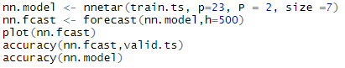

**Output:**



The chosen model, neutral network (ntetar) . The AIC value is 45 and the RMSE value is 67.62381.

**REJECTED MODELS**

* **Decomposition**

**R Code:**



**Output:**

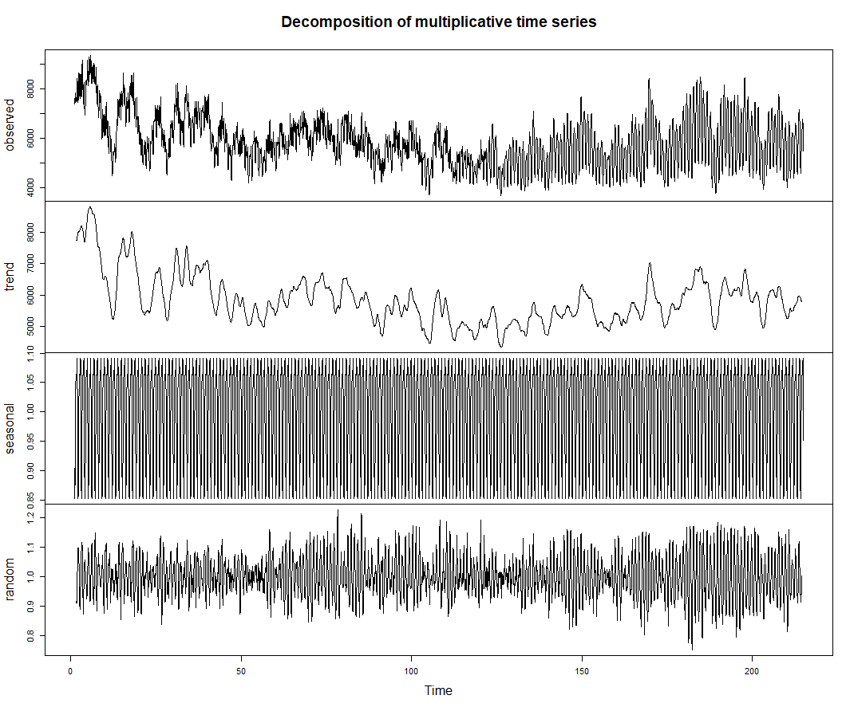

**R Code:**



**Output:**

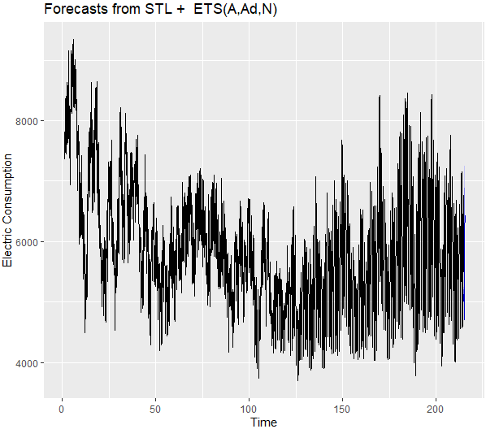





* **Linear Model**

**R Code:**

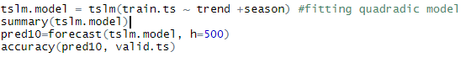

**Output:**



* **Exponential Smoothing**

**R Code:**

**Output:**

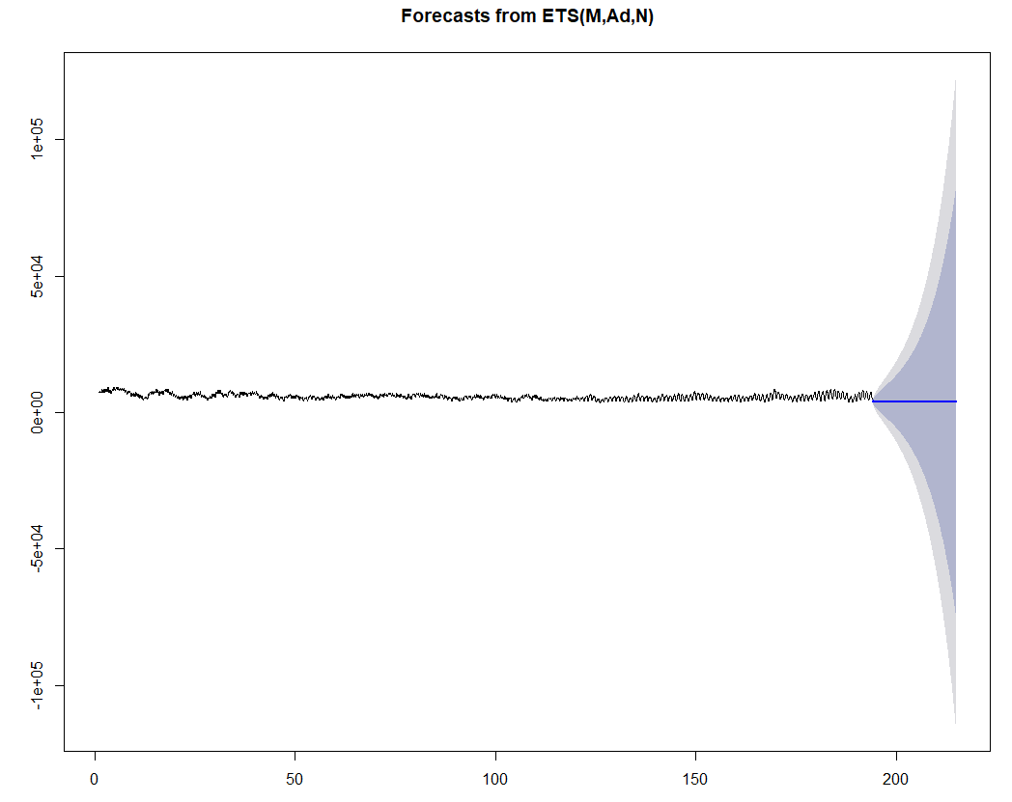





* **Naïve Method**

**R Code:**



**Output:**



* **Smoothing Method**

**R Code:**



**Output:**





* **ARIMA(1,1,0), Seasonal(0,1,2)**

**R Code:**



**Output:**

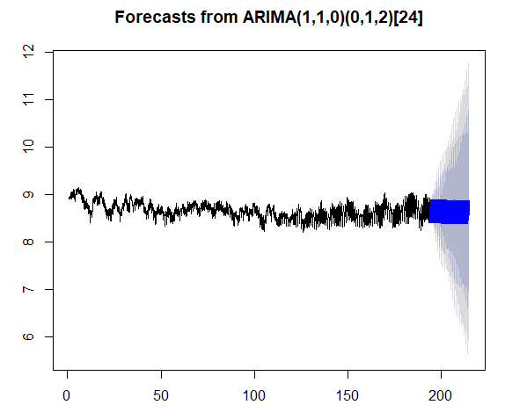



* **Dynamic Regression**

**R Code:**

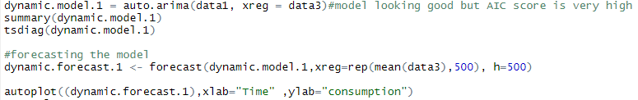

**Output:**

#try to fit various graphs

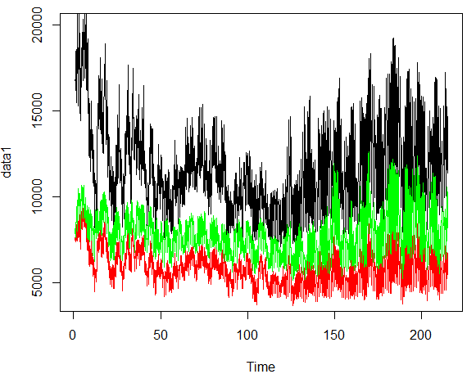

#check for correlation

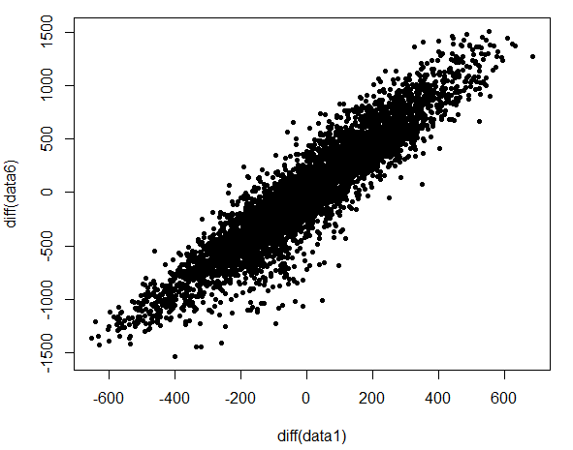

#Forecast

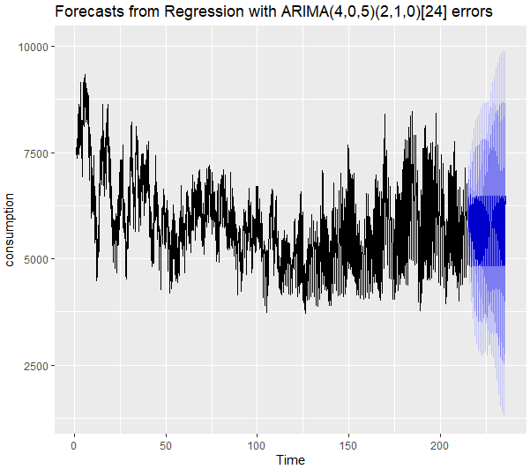

* **Random Forest**

**R Code:**

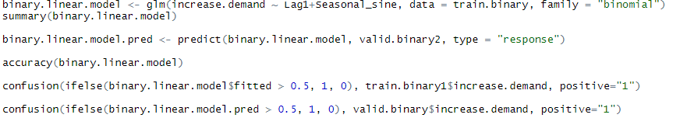

**Output:**









Accuracy = (223+218) / (223+20+20+218) = 441/481 = 91.68%

* **TBAT Model**

**R Code:**

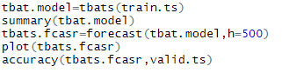

**Output:**



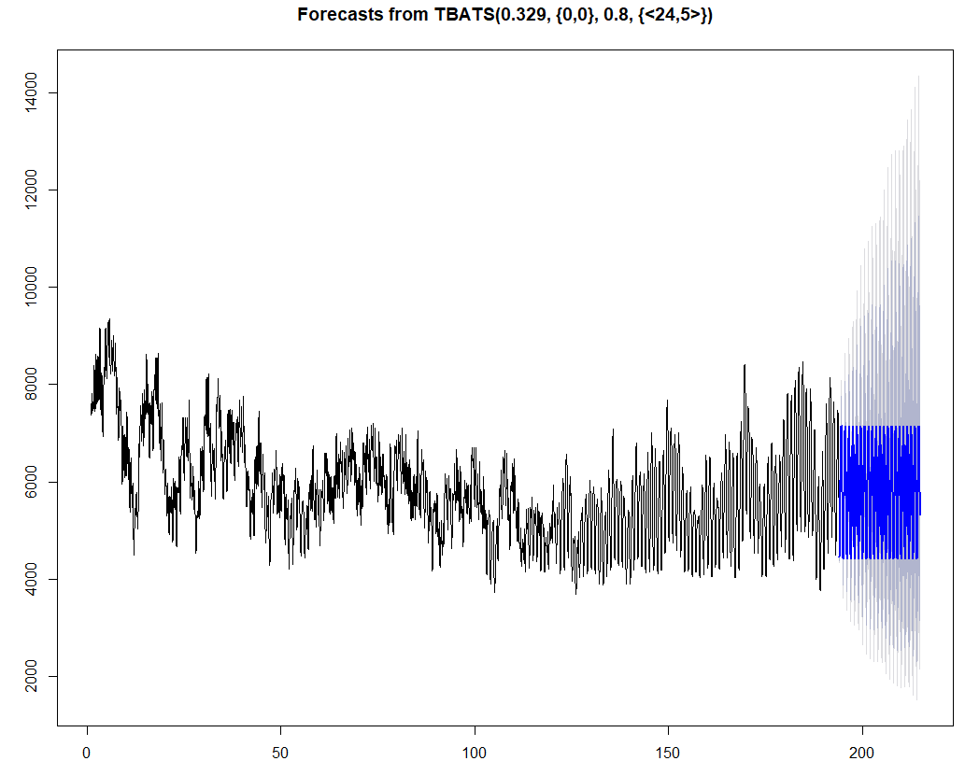

* **Holt’s Winters**

**R Code:**

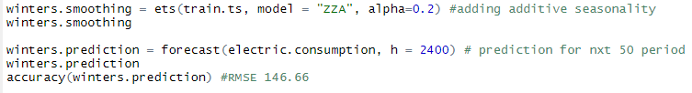

**Output:**

The RMSE value is 118.32 and AIC 924271.9



